ROS

ROS or Robot Operating System, unlike the name suggests is not an operating system. ROS is a middleware which acts as a bridge between the operating system and application level programs. ROS was developed to sophisticate the hardware and software architecture of the robot. ROS provides a simple yet elegant message packing and transportation service which helps to pass around sensor data to more than any one processes that require that data for robot control. Following are a few terminologies that are required to understand ROS:

• ROS Node: It is an executable code or program that runs in the background. A ROS node can contain a publisher, or a subscriber, or both.

• ROS Topic: A ROS Topic can be thought of as a newspaper column with a single dedicated editor (Publisher) and many readers (Subscriber).

• Publisher: A ROS Node may Publish a ROS message to a ROS Topic.

• Subscriber: A Subscriber subscribes to a ROS Topic and stays up-to-date with the incoming ROS messages.

• ROS Message: A ROS message is broadcasted by the Publisher to a ROS Topic. It can be composed of sensor readings, or control parameters, or any data in any format.

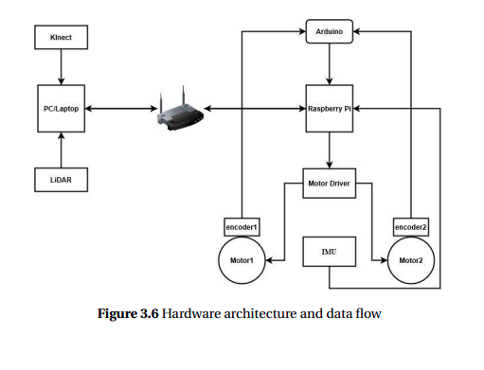
Fig. 3.6 shows how the hardware components are connected and interacting with each other. The direction of arrows represent the data flow.

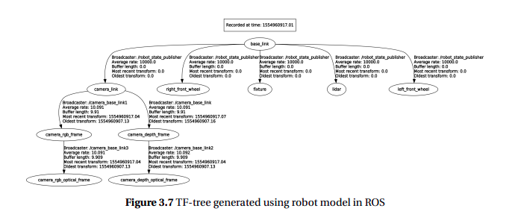
ROS follows a standard called URDF for generating robot models. URDF stands for Unified Robot Description Format which uses static transformations between frames and continuously publishes the same. Using robot model made shown in Fig. 3.4, ROS generates a transformation tree also called tf_tree which shows the links and latest transformations (if any) published between these frames. Fig. 3.7 shows such a tree generated.

The next chapter will discuss how all these components, sensors and actuators, interact with each other with the help of ROS for SLAM implementation. Further, we will discuss each SLAM algorithm in detail.

_______________________________________________________________________________

Mapping, localization, and Path Planning packages are used in this project. Each package consists of several nodes, topics (communication channels), and services. The implementation of each node is described below.

As shown in Figure 19, the mapping package includes four major nodes. Rplidar node for scanning information. This node use RPLIDAR to scan surrounding and publish the data name as /scan, sample output of Lidar scanner shows in Figure 20. Hector_mapping node subscribe to the necessary node for integrating data and publish map and UGV position, Hector_jrajectory_server node for publishing UGV trajectory information. Detail of the launch file and file configuration show in the appendix E.

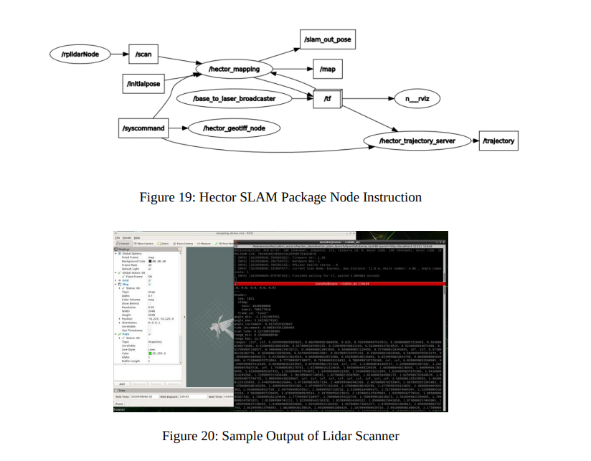

As shown in Figure 21, the localization package includes four major nodes. Rplidar node for scanning information, map_server node provides the created map, and the serial node lets the micro-controller communicate with ROS. AMCL node subscribe to other nodes and publish particle cloud information, send transform information node for integrating data from other node and publish map and UGV position. The detail of the launch file and configuration shown in the appendix F.

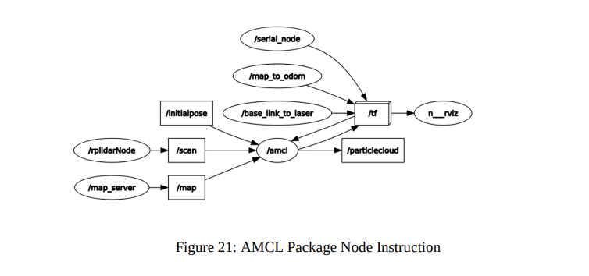

After starting the Rviz visualization tool, the trajectory and the 2D map are updated and shown on the screen simultaneously (see Figure 22).

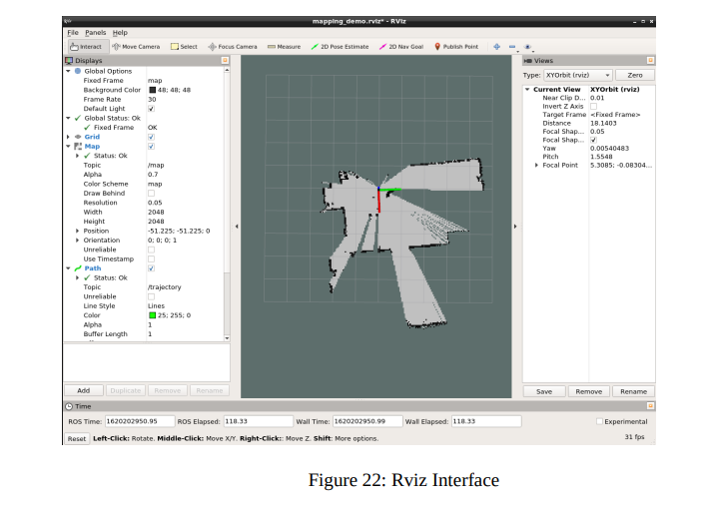

Virtual Network Computing, or VNC, is a sharing system that allows user to remotely control one computer from another. A VNC server is installed on the system under test (SUT) and works with Eggplant Functional to allow control of this second machine. In this project. Desktop is used to access onboard computer and control onboard computer remotely

Robotic Operating System, or ROS, in simplest terms is a framework for robot software development. The tools, libraries and conventions that make up ROS are utilized to create robust robot behavior for numerous platforms. The keyword that pertains to ROS is collaborative. It was created so that individuals developing robot software could effectively combine their contributions. Users are able to easily integrate nodes written by others into their own ROS system. This allows pioneering robotics software researchers to come together and further push the boundaries of this technology. Furthermore, one of the greatest benefits of this framework is the immense contributing community. The large number of contributors constantly enables advancement through troubleshooting and informative posts on ROS Answers [33]. The contribution of this thesis revolves around creating a robust system using ROS. The simulations to evaluate the ROS Gmapping node center around the implementation of this framework on a model of a robot designed for mining on Mars. Understanding how ROS works on a basic level is key to understanding the work in this thesis.

1) ROS Basics

ROS has a modular structure. It is essentially a network of nodes that communicate with each other. Having such structure eases the implementation of the complex system required to autonomously control mobile robots. This is because each node is designed to achieve its own specific, smaller task. Subdividing the problem into numerous smaller problems simplifies the task at hand. As each node is independent, debugging difficulty is reduced. Knowing where to concentrate on in order to solve an issue drastically reduces the time spent and confusion experienced during this process.

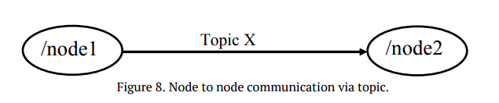
As noted above, ROS is a framework. Users take advantage of packages to create a system of nodes. This system of nodes is the entire makeup of the robot’s operating system. Each node performs a specific task and communicates with the other nodes to control the robot [34]. A ROS node is by definition a process that performs computation. In this application, it is essentially an executable that communicates with other nodes in the system. Nodes can publish data to a topic which therein transmits messages between nodes [34]. This is shown in Figure 8.

Nodes have no idea with whom they are communicating. When a node publishes data to a topic, the data is available for any other node to subscribe. Nodes that subscribe to topics are exposed to any and all data contained within the topic [35]. In order to stream this communication between nodes, the topics utilize TCP or UDP transport, both of which are types of internet protocol traffic. TCP sends data bidirectionally when a connection is established while UDP does not need a connection and sends data in packets [35]. To format the sent and received messages, ROS gives each topic a message type. These message types allow the differentiation between data [36]. Additionally, to solve the need for a request and reply, ROS employs what it calls a service. A service is simply a pair of messages where one is purposed for the request and the other for the reply. Nodes make use of a service by either waiting for an expected request or sending a reply. Once said request is made, the node awaits the reply [37]. To store data to be used offline or elsewhere, ROS indentures the use of a bag. ROS bags are generated by subscribing to one or more topics. This data is “bagged up” to be saved for later or sent to other nodes. This is a way to bypass subscribing to a certain topic [38]. Lastly, to fully understand the ROS architecture and terminology one must be familiar with the Master. The Master helps the nodes that are interacting with each other to locate one another. It can match publishers and subscribers to topics and services [39]. The Master maintains the operational complexity of this publishersubscriber framework and makes this all possible.

2) ROS & Mobile Robots

Developing a robot to mine on the surface of Mars requires autonomous control and movement. ROS utilizes the Navigation Stack exactly for this purpose. The Navigation Stack is a package designed for controlling a mobile base (a robot with a square or rectangular footprint) but can be tailored for other applications. At a highlevel, the Navigation Stack uses the odometry and sensor data to output velocity commands to the robot [40].

To utilize the functionality of the Navigation Stack, the robot must meet certain software and hardware requirements. Intuitively, to use the Navigation Stack the robot must be running a properly installed version of ROS that publishes sensor data with the correct ROS message types [40]. Additionally, a transform tree must be configured. ROS makes this easy through providing the “tf” library. The purpose of a transform tree is to account for the fact that the sensors, wheels and base of the robot are all on different coordinate frames [41]. If these differences are not maintained, the robot would be using data received in one coordinate frame to move the robot in another. This would result in extremely inaccurate navigation and cause innumerable problems. The benefit of using the tf library and implementing a transform tree is one needs only knowledge of a single coordinate frame to accurately use data from another.

Moreover, there are certain hardware requirements to ensure the Navigation Stack is performing properly. First, velocity commands to the robot are assumed to be sent with an x-component, y-component and theta. Second, the robot should have a square or circular footprint. Finally, the robot must be receiving data about the environment from an exteroceptive sensor. Once all of this is in place, the robot is now ready to use the Navigation Stack for movement.

The Navigation Stack is fairly simple at a conceptual level but extremely complex in its implementation. Figure 9 provides an overview of how the Navigation Stack is configured.

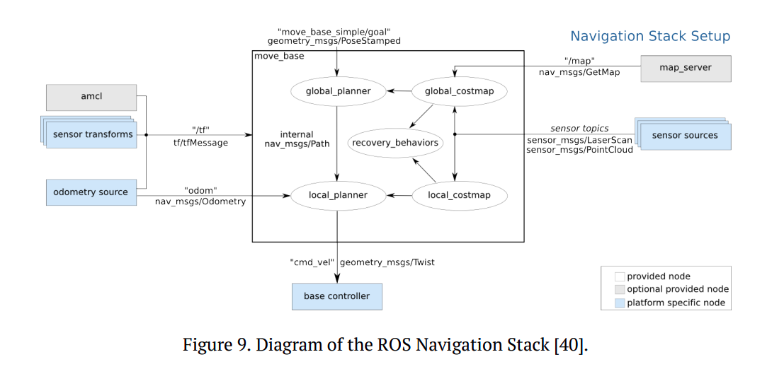

To understand how this package utilizes sensor data to control the robot the basic structure of ROS must be considered. Remember that ROS is fundamentally a network of nodes. Figure 9 shows that each node either subscribes and or publishes to a topic. Each node in the Navigation Stack serves a specific purpose that when put together work uniformly to implement its functionality. The Navigation Stack provides both costmaps and planners as their own respective nodes. A costmap contains obstacle data represented in a 2D plane that is continuously updated as sensor data is received. Cells occupied by an obstacle have an inherent cost which is then inflated to a specified radius. As the distance from the obstacle increases, the cost associated with the grid decreases exponentially [42]. The overall objective is to create a path to the navigation goal associated with the least cost. There are both a global and local costmap. Intuitively, the global costmap represents the environment as a whole while the local costmap is concerned with a more refined and detailed snapshot of the local range around the robot. The size of this range is configurable, but the standard parameters create a 6 x 6-meter costmap with a resolution of 0.05 meters [43].

Furthermore, the Navigation Stack includes two planners. These work with the costmap to create a path to the goal. The planner takes into account the costs associated in the costmap to produce the most cost-effective trajectory [42]. There is both a local and global planner. The global planner develops an extremely optimistic path as more of a high-level guide for the robot. This path could potentially be infeasible and does not account for the kinematics and dynamics of the robot [42]. In the Navigation Stack, the global planner makes use of Dijkstra’s algorithm to implement A* [44][45]. The local planner on the other hand utilizes the path generated from the global planner as a guide, but often develops a plan with deviations from the global path. These deviations generally happen when obstacle avoidance is necessary. If the local planner has to deviate from the global path, it works as hard as possible to get the robot back on the global path. It is the local planner that takes into account the kinematics and dynamics of the system to generate the velocity commands output to the robot controller [42]. The local planner makes sure to generate safe velocity commands through taking advantage of the Dynamic Window approach, or DWA [45][46]. The DWA essentially utilizes a cost function to compute the most costeffective velocity commands necessary for the robot to reach its goal [42]. Also note that there are certain recovery behaviors built into the Navigation Stack to prevent the robot from getting stuck.

As you can now see, each node in the Navigation Stack works with one or more nodes to achieve its specified purpose. There is no linear path of communication between said nodes. A high-level description of the Navigation Stack is shown in Figure 10.

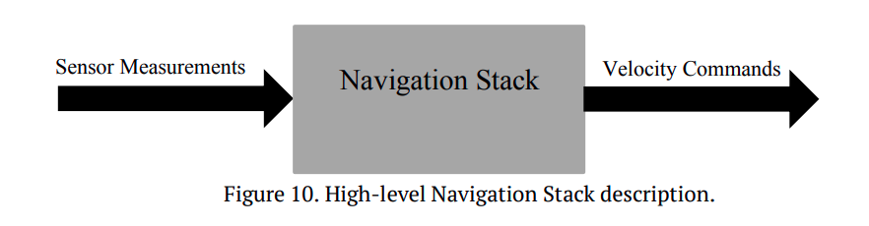

The main idea is sensor measurements generated from the real (or simulated) world are sent to the Navigation Stack. This data is then interpreted and used alongside the costmaps and planners to control the robot while simultaneously accounting for any obstacles encountered [42]. Figure 9 illustrates an application where a predefined map is utilized. Meaning the environment is known and the Navigation Stack uses a localization algorithm to control and move the robot while knowing where all obstacles are. However, this is not the only way to configure the Navigation Stack. One can take the amcl and map nodes you see in Figure 9 and essentially combine them to make a single node. Replace those aforementioned nodes with a SLAM node and one has achieved simultaneous localization and mapping on a ROS-based robot. In this case, the map starts as a blank slate and is constantly updated while localization data and the Navigation Stack guide the robot through the environment. Concurrently looking out for known and newly detected obstacles and updating the map allows the Navigation Stack to implement real-time obstacle avoidance. At first, the robot can only rely on the data it is seeing initially to ensure its path planning algorithms do not lead it into any obstacles. Once the map becomes more complete and the data associations become stronger, the robot can fully rely on the data within the generated map to aid in navigation.

These are precisely the requirements needed to be fulfilled for a robot mining on the surface of Mars for ISRU. Initially, the robot will start up from the deposition site, not knowing anything about the environment. It will be commanded to traverse to the mining site. The SLAM algorithm will work with the Navigation Stack to avoid rocks and craters while maintaining the course to its goal. A map will be generated throughout this process that provides reliable data back to the system to support accurate control and localization. The only human interaction will be in the form of two teleoperated commands. Those being one command from NASA scientists to the mining area, and another commanding the robot to navigate back to the deposition site. Thus, this solution should provide a high level of autonomy.

Within ROS, the most commonly used and widely accepted SLAM nodes are Gmapping & Hector SLAM. Each are open-source algorithms provided by the ROS community. The benefit of choosing ROS for SLAM is much is already tailored for quick implementation. Depending on the application many nodes can be treated as a “black box”. For instance, with both Gmapping and Hector SLAM, the user can take the nodes and perform SLAM on their system without knowing or understanding the internal details and implementation of the algorithms. This is extremely useful for those needing SLAM for their application but don’t have the time or knowledge necessary to implement their own solution. The structure of ROS allows experts in other fields to conduct research in their respective area that may require SLAM. They are able to do so without needing to know the intricate details and theory behind the ROS node.

To integrate SLAM into the Navigation Stack, one essentially removes the amcl and map nodes in Figure 9 and generates the necessary topics through either Gmapping or Hector SLAM. Gmapping uses the SLAM technique involving the optimization of laser scanner data combined with odometry data from the robot. This algorithm uses this data to generate a 2D grid map of the environment in which the robot is operating [47]. Alternatively, Hector SLAM takes advantage of the high update rate of laser scanners to provide an accurate estimate of the robot's location and pose while also mapping the environment [48]. A key aspect of Hector SLAM is that it does not need to use odometry. This is useful for robots that are unable to generate odometry data like UAVs. Utilizing the high update rate of scanners can accommodate the gaps in useful data created by the lack of odometry. Both are adequate solutions to mapping and localization in an unknown environment. The research in this thesis centers around simulation of a robot using the Navigation Stack mentioned above implemented with the ROS node Gmapping.

The last key feature of ROS is it provides a tool called Rviz for the visualization of data. This tool enables the user to view things such as the laser scanner data, occupancy grids, and to map local and globally planned paths. Although this tool has numerous capabilities, it was used in this research for teleoperation of the robot as well as viewing and evaluating the map. Rviz allows the ability to pick waypoints on the map as robot goals. These waypoints represent a desired pose in the world frame. This teleoperation mimics the waypoints dictated by NASA scientists and represents the only human involvement in this process. Here, the ROS Navigation Stack subscribes to the desired pose and autonomously navigates until reaching the commanded goal. Rviz also displays the occupancy grid message by the Gmapping node. This is the most straightforward way to observe the map and its creation in real-time. The Rviz measurement tool can be used to record absolute distances between two points on the map. This affords the ability to measure the distances between an object’s mapped location and a reference point (origin). The recorded data can then be used to provide a way to evaluate the validity and accuracy of maps generated by Gmapping.

3) FastSLAM and its Derivatives

This thesis focuses on Gmapping and how effectively the algorithm simultaneously localizes and maps in an extraterrestrial robotic mining application. Therefore, it is important to understand the underlying theory and structure behind the algorithm. Gmapping is derived from the RBPF based FastSLAM algorithm. As mentioned previously, EKF’s are proven robust solutions to the SLAM problem, however, they are only effective when dealing with Gaussian systems [49]. To expand upon the capabilities of SLAM, PF based approaches were introduced.

PFs utilize a system where each particle is a sample containing both its own map of the environment and a robot pose [49][50]. Every time the robot moves, the particles are updated with a new map and pose corrected to the movement. In addition to every particle possessing its own representation of the map and the robot orientation, each individual particle in the system is associated with a weight. This weight is utilized by the algorithm to filter out the weakest samples converge toward the strongest representation [14][49]. One can think of this as a sort of natural selection of particles. Maintaining a set number of particles eliminates the possibility of having infinite particles with representations of a map and pose. Filtering out the less likely particles makes room for resampling and further confirms strong state estimations. The significant number of particles, each of which contain their own map and pose estimate, leads to high computational complexity. To reduce the computational complexity of this problem, Rao-Blackwellized particle filters were introduced. The first solution involving RBPFs was postulated by Doucet in his work [49][50]. Doucet and Murphy argue Rao-Blackwellization particle filtering utilizes the same premise of the particle filter explained above, however it takes advantage of the marginalization of state variables. This marginalization optimizes the computational complexity by reducing the overall size of the sample space [49]. That being said, this approach still requires 0 (MK) time, with M being the number of particles and K the number of landmarks. FastSLAM improves upon this through use of a tree-based structure. This structure results in 0(M log K) run time [17].

There are three generalized steps that describe the RBPF process. These include: initial sampling from the proposal distribution; the computation of the particle weight; and resampling. The first step is where the process estimates the trajectory of the robot and the map of the environment given the observations from the laser scanner and the odometry data from the robot. The second step assigns a weight to each particle. This weight indicates the likelihood of the calculated trajectory and proposed map. Finally, these weights are employed during the resampling process where the RBPF takes the strongest samples and saves them while discarding the weaker samples. The filter then resamples the discarded samples in hopes of gaining newer samples with strong likelihoods to confirm our most likely robot state estimate [14][49]. Figure 11 attempts to graphically explain this process.

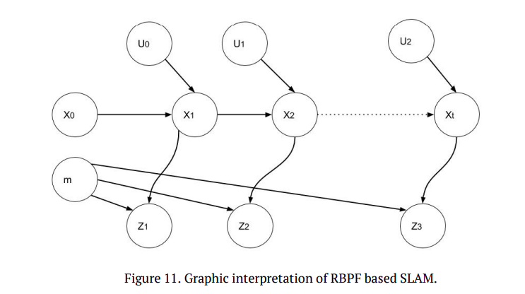

In Figure 11, X, M, Z and U describe the robot pose, map, observations, and movements respectively. The diagram shows each time new movement data is generated, the robot pose estimate is updated. The new pose is then used alongside sensor data to update the map. This process is iterated as the robot moves throughout the environment.

To approximate where the robot is located while concurrently building a map of the environment, one must utilize the joint posterior distribution about the trajectory and map. This distribution is simply a distribution of unknown quantities (trajectories and map) that are treated as a random variable. The result of the unknown quantities depends on the data from the environment (scan and odometry data). This distribution is as follows:

Where x_{1:t} = x_1,……,x_t is the trajectory of the robot, is the map of the environment, z_{1:t} = z_1,……,z_t is the data received from the laser scanners, and is the robot odometry data [15]. Realize that this distribution contrasts the problem of only localization which has the distribution:

As stated earlier, the difficulty with robot localization increases exponentially when the map is unknown as well. To reduce the complexity of the distribution for the SLAM problem, Murphy proposed a factorization in his work [16]. The factorization provides:

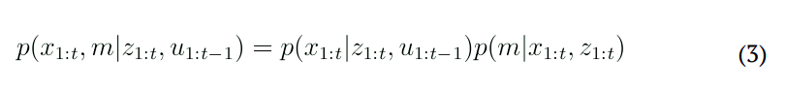

Notice that the initial distribution of two unknowns and two known quantities is now split into two distributions with only one unknown. The first, p(x_{1:t} | z_{1:t}, u_{1:t-1})
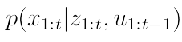

can be looked at as only a localization problem, similar to the one provided in (2). This is because there is only one unknown quantity in the distribution. That being the current pose which depends on the odometry and scan data. Here, the robot trajectory is estimated with a particle filter that processes odometry and observation data as they are available [14][51]. Additionally, the second part of the factorized distribution
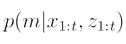

can be looked at as a mapping problem solved using known poses of the robot [51]. The map is updated based on the newest trajectory estimated and locations of landmarks within the map are realized through individual EKFs.

Working with a mapping system that takes advantage of a RBPF warrants the need for a proposal distribution to draw the next set of samples. The standard framework of the system allows the user to choose the distribution and how to calculate it. In standard Monte-Carlo localization, the distribution
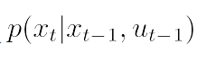
is used to predict the motion of the robot. The issue here is the distribution does not take advantage of the observations from the robot’s laser scanner. This confirms the idea that a problem-specific distribution is necessary to obtain an accurate motion model [12]. The Gmapping algorithm in ROS is analogous to the FastSLAM algorithm save that it formulates FastSLAM to work in a grid-based scenario, introduces adaptive resampling, and an improved proposal distribution. Doucet and colleagues contrived an optimal proposal distribution for this problem in [50]. Under Markov assumption the distribution is:

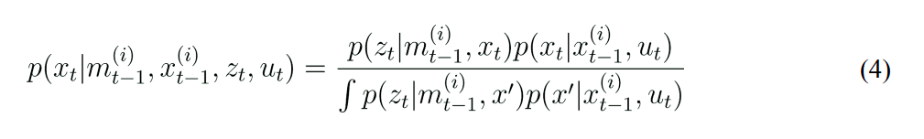

Note that
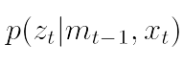

is the observed likelihood of the laser range finder while the motion model is described through the distribution
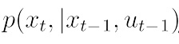

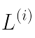
The likelihood of the laser scanner is much greater than that of the motion model, causing it to be the dominating term in the optimal proposal distribution. Gmapping improves this distribution by taking this term and representing it with constant inside the meaningful area

to allow the following approximation:
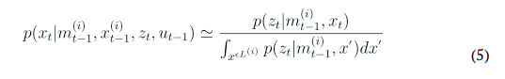
Additionally, the distribution around the maximum of the likelihood function is locally approximated by a Gaussian [51]. These formulated distributions are now adequate enough to estimate the map and the robot’s pose. Each time the robot moves, these distributions provide the necessary estimate. Recognize that this distribution takes advantage of the most recent observation to provide accurate pose estimates [51]. The parameters of the Gaussian can be found through the evaluation of the likelihood function for a set of points. The points of which are sampled around the corresponding maximum determined from scan matching [14][51]. As the samples are generated each is then weighted based on importance.

Importance sampling is purposed for the task of eliminating weak samples. Ideally, there is an exact distribution to sample from, however that distribution isn’t always known [14]. The idea behind importance sampling is to sample from the available distribution and reweight samples to account for the fact that the used distribution is not the exact desired solution [12]. Importance weight is calculated with the equation below:

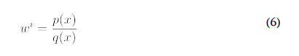

Where p(x) is the required solution and q(x) is the known distribution. The process uses this relationship to account for any error and make the best approximation possible. As stated, the particles with greater “importance” or weight are more heavily relied upon to produce the approximation of the robot’s pose and the environment.

The last step in Rao-Blackwellized based SLAM is particle resampling. In a perfect world, sampling after every step would be best, however, each resampling causes an increase in variance. To combat this issue, the algorithm picks when to resample. Gmapping resamples when the effective number of particles is less than N/2 with N being the number of particles used [18][51]. The effective number of particles measures the samples from the proposal distribution and how likely they are to describe the goal distribution. Particle resampling utilizes the current set of particles to create a new set. This is done by simply drawing from the old set while favoring the samples with higher weights. The process leads to another randomly generated sample set often more accurate than the previous distribution due to the favoring of higher weights. Doing this completes the SLAM process and accurately localizes the robot while mapping the environment.

4) Gmapping

The Gmapping ROS node was authored by Brian Gerkey. It is a wrapper for OpenSlam’s Gmapping and is licensed under the CreativeCommons-by-nc-sa-2.0. The original authors of OpenSlam’s Gmapping algorithm are Giorgio Grisetti, Cyrill Stachniss, and Wolfram Burgard. As stated above, the algorithm generates a map of an unknown environment from laser and odometry data. Therefore, a sufficient laser scanner and vehicle that can produce odometry data is necessary for this solution. This laser scanner must be fixed and planar mounted meaning the transform between the robot and laser frame cannot be dynamic. The node was derived from the RBPF-based SLAM technique FastSLAM. The difference between the two is Gmapping reduces the number of particles necessary and optimizes results through varying the proposal distribution with the current situation. The key difference is how the algorithm works when the robot is operating in already visited areas. In this case, the algorithm choses a new pose that maximizes the likelihood of observation predicted by odometry. The algorithm is able to stay localized within the known area which results in a constant effective number of particles [14][51]. Maintaining a constant value above the designated threshold reduces resampling and keeps accurate estimates.

Recall that each particle carries its own map of the environment independent from all the others. One can ascertain that the use of a method involving numerous individual maps can add extreme computational complexity to the solution. Thus, it is imperative to develop this in a way that uses minimal numbers of particles. Although the number of particles used it a tunable parameter, this research uses 30 particles, the recommended solution [52].

Additionally, one must be weary of the particle depletion problem for RBPFs [51]. This problem postulates that the resampling in the algorithm could potentially eliminate a particle that is most accurately representing a map of the environment [51]. Gmapping utilizes a “highly accurate” proposal distribution to combat this. The benefit to said distribution lies within observing the sample size [53]. Looking at the sample size gives the algorithm an indicator for when effective resampling is needed, therein reducing the risk of particle depletion and combating the problem [53].

Drawbacks to Gmapping include computational complexity that is often a function of the number of particles used and the need for a planar mounted laser. The need for mounting a laser as such leads to difficulty when operating in unstructured environments, however Gmapping is proven robust [52]. If sufficient and accurate sensor data is being passed to the algorithm, its robustness will inherently produce viable SLAM data.

5) Alternate ROS-based SLAM approach

Hector SLAM is yet another ROS node that offers SLAM capabilities. Authored by Stefan Kohlbrecher, it is a solution that avoids having to use odometry data [48]. The algorithm does so by taking advantage of scanners with high update rates of 40 Hz or more to give estimates for the robot pose at the rate of said scanner [48][52]. Consequently, not having a laser with high update rates makes the use of this algorithm inappropriate.

Not using odometry can be useful in situations where accurate information is difficult to generate, particularly in the operation of UAVs and certain rugged mobile robots. Providing an adequate SLAM solution that bypasses the need for odometry data can be extremely useful in certain scenarios [47]. This, however, is not an advantage if the system requires odometry data for navigation. Mobile autonomous robots operating on Mars require odometry data to intelligently move on their own. This is largely in part due to the lack of other data like GPS that autonomous robots can rely on for movement when odometry is not present. Since odometry is necessary for autonomous operation on Mars, the ability to implement SLAM without odometry is a moot point. Sources indicate Hector SLAM does not need odometry but is able to accept it. As Hector SLAM does not make use of the transform from base link to odometry it is assumed the provided odometry is ignored [54]. In this case, the node’s ability to accept odometry is likely to provide easy interface between Hector SLAM and the more prevalent Gmapping [54].

Hector SLAM has limitations for Martian robotic mining. First, Hector SLAM does not provide any loop closing abilities [48]. Loop closure refers to the ability of the algorithm to recognize when it has reached a previously seen environment. The ability to do so is inherently difficult but imperative [55]. Closing the loop and recognizing old environments is important when working with a robot that will at some point return to its starting position. In the case of mining Mars for ISRU, the robot will constantly traverse back and forth between the same areas. Recognizing it is back in an area it has seen before is important for generating accurate SLAM data. The reason loop closure is difficult is because current solutions heavily rely on pose estimates [52]. Hector SLAM’s large reliance on laser scan data and a lack of odometry makes this impossible.

Secondly, when operating in conditions with limited number of landmarks as would be 50 encountered inside a mining zone, error in Hector SLAM grows continuously. This is largely due to the lack of useful data pushed to the scan matching aspect of the algorithm [52].

Weighing the pros and cons of both Hector SLAM and Gmapping is important when deciding what SLAM technique is optimized for mining material on Mars. Due to the nature of the terrain, the robot will experience variations in roll and pitch combined with a great amount of wheel slippage. The generic capabilities of Hector SLAM would point toward utilizing that approach in this situation. Error in localization due to wheel slippage and continuous roll/pitch make it difficult to provide accurate data for SLAM. Furthermore, Hector SLAM is optimized for conditions exhibiting roll and pitch, mainly from the use of a dynamic transform between the laser and the robot [56]. This however, requires a more sophisticated sensor package containing an IMU to estimate the positioning of the laser allowing the implementation of this transform possible.

Notwithstanding, this research foremost focuses on the effectiveness of Gmapping for robotic mining robots, but also centers on the effect two different sensor packages have on the algorithm’s robustness and accuracy. With one sensor package, accurate odometry data is generated from the use of an IMU. The fusion of IMU data with wheel encoder data provides adequate information in rough terrains. Therefore, this capability neutralizes Hector SLAM’s advantage of no odometry or odometry based solely on an IMU alone. Furthermore, the other sensor package does not make use of an IMU and therefore does not provide the adequate data necessary for implementing Hector SLAM.

Gmapping and Hector SLAM present similarities, but highlight having different capabilities that must be taken advantage of depending on the application. Overall, this implementation is able to fill in the gaps of Gmapping through the varying sensor packages that would generally make the case for Hector SLAM. Lastly, Hector SLAM shows increasingly poor performance in areas without many landmarks and in situations requiring quicker operation. Due to the nature of the problem, areas without many landmarks could often be encountered and operating at a reasonable speed is necessary. If the robot is only able to reach the mining area once a day due to the limitations of Hector SLAM it will be increasingly difficult to mine enough regolith for ISRU

This inadequacy could lead to drastic issues with generated SLAM data and makes the case for solely investigating the more robust Gmapping algorithm and its potential in an extraterrestrial mining application for ISRU.

6) ROS & Gazebo

A convenient feature about working with a ROS-based robot is the user does not need a physical robot to implement the operating system. ROS packages have been written to provide wrappers that make it extremely simple to simulate robots in Gazebo. Gazebo is a free robotic physics simulator [57]. With Gazebo a user can do all sorts of testing and proof of concept before spending time and money on hardware and development. This research took advantage of these capabilities to evaluate the effectiveness of Gmapping for a Martian robotic mining expedition solely through simulation.

This invaluable tool provides the ability to create or import a model of a robot and simulate control through the robust physics engine [57]. Furthermore, Gazebo has the ability to simulate sensors and generate data replicating operation in the real world. All of which replicate the sensor’s physical counterpart as closely as possible [58]. With the use of plugins, one can interface with the ROS framework and simulate this data for use on a ROS controlled robot. If properly setup, these plugins take data generated in Gazebo to publish and subscribe to necessary topics for ROS. In this research, plugins were used to generate LiDAR data in the environment, simulate data from an IMU, and implement skid-steer control on the model of the robot base. The LiDAR plugin generated sensor data from objects in the world that was then used by Gmapping and the move base node to implement SLAM, path planning, and obstacle avoidance. The IMU was used to produce acceleration information later purposed to create more robust odometry data, all of which is detailed in the next section. Lastly, the skid-steer controller was utilized to replicate the skid-steer characteristics of the physical robot in the real world to replicate operation as closely as possible. One can essentially replicate any conditions from the real world for use in this simulator.

Additionally, Gazebo allows the creation of complex indoor and outdoor environments [59]. One can add objects, obstacles, floor plans and much more to create almost any environment desirable. These abilities were utilized to create a Gazebo world replicating the conditions on Mars. Details on this process are presented in a later section. Notwithstanding, the ability to simulate robots in an array of environments and provide the functionality for testing numerous applications and scenarios makes Gazebo invaluable.

Gazebo is such an incredible tool that infinitely increases potential access to the world of robotics. Many people do not have the resources to build or design their own physical robot, and Gazebo allows those people to contribute to the world of robotics.

